Ensemble Learning
Combining Multiple Learners – Ensemble Method
This slide introduces the Ensemble Learning approach, which involves combining multiple algorithms (or learners) to perform a learning task. The key points are:
- Several Algorithms for the Same Task:
  - In most machine learning problems, there are multiple algorithms that can be used to solve the same problem.
  - No single algorithm is guaranteed to be the best in every situation.
- No Free Lunch Theorem:
  - This theorem in machine learning asserts that no one algorithm will outperform all others across every problem domain.
  - Hence, the usual approach is to try several algorithms and select the best-performing one on a validation set.
- Combining Multiple Learning Algorithms:
  - Instead of relying on a single algorithm, combining multiple learning algorithms can yield better accuracy.
  - These can be the same algorithms with different configurations or completely different algorithms.
- Improving Accuracy through Complementary Models:
  - The idea is that combining models that complement each other can lead to improved accuracy. For example, if one model fails on certain examples, another model may succeed in those cases.
  - Example: In Random Forests (a bagging technique), multiple decision trees are combined. Each decision tree may give a slightly different prediction based on different subsets of the training data, but together, their combined prediction (through majority voting or averaging) leads to a more robust result.

Why Combine Many Learners Together?
- Single Algorithm Assumptions:
  - Each learning algorithm works based on certain assumptions. If the assumptions don't hold in the real data, the model may give incorrect predictions.
  - Example: A decision tree assumes that data can be divided into a series of binary splits, but if this assumption doesn't hold, the tree might overfit or underperform.
- Ill-Posed Problem:
  - Machine learning is often an ill-posed problem, meaning there is not always a clear solution.
  - Different algorithms might converge on different solutions, and combining them may lead to better results.
- Fine-Tuning and Performance:
  - Tuning a single model to perform well on a validation set can be complex. Moreover, even a well-tuned model may not perform optimally on certain cases in the real world.
  - Example: Fine-tuning the hyperparameters of a support vector machine (SVM) may give good performance on a specific dataset, but for unseen data, it may still struggle. Combining the SVM with another learner, such as a decision tree, could give better generalization.
- No Single Best Algorithm:
  - It has been proven that no single algorithm can always produce the most accurate output. Therefore, the idea of ensemble learning helps to overcome this limitation by leveraging the strengths of multiple algorithms.
  - Example: In Gradient Boosting, multiple weak learners (often decision trees) are trained sequentially. Each new learner focuses on the mistakes of the previous ones, thereby improving the overall prediction accuracy.
Ways to Achieve Diversity
- Base Learners:
  - The individual algorithms in the ensemble are called base learners.
  - The diversity of these base learners is crucial for improving the overall accuracy of the ensemble model.
- Methods for Selecting Base Learners:
  - Use Different Learning Algorithms:
    - Combining different types of algorithms, such as decision trees, SVMs, and neural networks, can lead to a more robust ensemble because each algorithm might capture different aspects of the data.
    - Example: In an ensemble with decision trees and SVMs, the decision tree might capture non-linear patterns in the data, while the SVM can handle high-dimensional spaces more effectively.
  - Use the Same Algorithm with Different Hyperparameters:
    - Another method is to train the same type of algorithm with different hyperparameters.
    - Example: In a Random Forest (bagging of decision trees), each tree is built using different subsets of the data and different random splits, but they are all decision trees. This leads to diverse outputs even though the underlying model is the same.
  - Use Different Representations of the Input:
    - The same input data can be transformed or represented in different ways, which can lead to different predictions by the learners.
    - Example: In image recognition, you could apply different filters to the images (e.g., edge detection or color segmentation) and feed these variations into different models.
  - Use Different Training Sets:
    - You can also achieve diversity by using different subsets of the training data for each base learner.
    - Example: In bagging, each model is trained on a different bootstrapped sample (a random subset with replacement) of the training data. This ensures that the models are exposed to slightly different data, promoting diversity.
Model Combination Schemes - Voting
- Voting:
  - Voting is one of the simplest ways to combine the results of multiple machine learning models. It works by asking each model to make a prediction, and then the final decision is made based on which label gets the most votes.
1. Binary Classification Problem:
- Binary classification refers to a problem where there are only two possible outcomes or classes. In this case, the labels are -1 and +1, which are typical values used for representing two possible outcomes.
- Base Learners: Let’s say you have several different models (L models), and you are trying to classify a test instance (x).
- Voting Process:
  - Each model gives a prediction of whether x belongs to class -1 or +1.
  - If a model predicts that x belongs to +1, we count that as one vote for +1.
  - If it predicts -1, we count that as one vote for -1.
- Final Prediction:
  - After all the models have voted, the class with the most votes is the final predicted class for x.
  - This voting scheme ensures that we use the collective decision of all models rather than relying on a single one.
Model Combination Schemes - Multi-Class Classification
- Multi-class classification problem:
  - Multi-class classification deals with problems where there are more than two possible classes (e.g., classes C1, C2, ..., Cn).
  - Voting Process:
    - Just like in the binary case, we have multiple models (base learners) that each make a prediction for a given test instance (x).
    - Each model assigns x to one of the available classes (C1, C2, ..., Cn).
    - When a base learner assigns a class, that class gets one vote.
  - Final Prediction:
    - After all models have voted, the class with the highest number of votes is the predicted class for x.
    - This voting scheme is a straightforward way to combine multiple models for more complex classification tasks where multiple categories are possible.
Why Use Ensemble Methods?
This section explains the reasons for using ensemble methods, which involve combining multiple models (or learners) instead of relying on just one model.
- Better Accuracy (Low Error):
  - By combining multiple models, ensemble methods can often produce more accurate results compared to using a single model. This is because different models may make different types of errors, and combining them can help cancel out these errors.
- Higher Consistency (Avoids Overfitting):
  - Overfitting happens when a model performs well on the training data but poorly on new, unseen data. Ensemble methods help avoid this problem by averaging out the predictions of several models, leading to more general and consistent results across different datasets.
- Reduces Bias and Variance Errors:
  - Bias refers to errors caused by overly simplistic models that cannot capture the true complexity of the data.
  - Variance refers to errors caused by overly complex models that fit the training data too closely and fail to generalize to new data.
  - Ensemble methods reduce both bias and variance by combining the strengths of multiple models.

Homogeneous Ensembles
- What is a Homogeneous Ensemble?
  - In a homogeneous ensemble, you use the same type of learning algorithm multiple times but manipulate the training data each time to make each model (learner) unique.
  - The same learning algorithm is applied to different subsets or versions of the training data.
Examples of methods for changing training data:
  - Bagging: Resampling the data (creating different training sets by selecting samples randomly).
  - Boosting: Giving more weight to misclassified data so the model learns from its mistakes.
  - Random Forest: A collection of decision trees using bagging and random feature selection.
Example: Imagine you are training several decision trees on different subsets of the same dataset (e.g., Bagging). Even though the same algorithm (decision tree) is used, the slightly different data will lead to different results.

Bagging - Bootstrap Aggregation
- Bagging (Bootstrap Aggregation):
  - What is it? Bagging creates multiple versions of the training set by randomly sampling with replacement. This means that some data points may appear multiple times, while others might be left out.
  - Training Different Learners: Each learner (model) is trained on a different version of the training set, and in the end, we combine their results, usually by voting.
Example: Suppose you have a dataset of 100 students' grades. You can create multiple training datasets by randomly picking students (some may appear more than once, others may not appear at all). You train several decision trees on these datasets and combine their predictions.
Unstable Algorithms:
- Some algorithms, like decision trees, are unstable. This means that even a small change in the training data can lead to a big difference in the model.
- Bagging helps to reduce this instability by combining multiple models trained on different samples of the data.
Example: If you train a decision tree on slightly different subsets of data, you might get very different results. By using bagging, we average out these results, making the model more robust.
For Regression and Classification: Bagging can be used for both classification problems (e.g., deciding if an email is spam or not) and regression problems (e.g., predicting house prices). The final prediction is the average or majority vote of the models.
What is Boosting?
- Boosting is an iterative process where we train weak models (models that aren't very strong) sequentially. Each model tries to correct the mistakes made by the previous ones.
- Focus on Misclassified Data: After each model is trained, Boosting gives more importance to the data points that were classified incorrectly by earlier models, forcing the new model to focus on these harder cases.
Example: Imagine you're training a model to classify animals in pictures. If your first model misclassifies some cats as dogs, the next model will focus more on these specific pictures to get them right.

Boosting Procedure:
- Step 1: Start by training a model on the entire dataset with equal weights for all observations.
- Step 2: Identify where the model makes mistakes and increase the weight (importance) of these misclassified data points.
- Step 3: Train a new model that focuses on correcting these mistakes.
- Step 4: Continue this process for several iterations until the model improves its accuracy.
Example: Imagine you're predicting whether customers will buy a product based on their data. If the first model struggles with younger customers, the next model will give more weight to these younger customers' data and try to do better.

Bagging vs Boosting
- Data Partition:
  - Bagging: Data is randomly split into subsets, and each subset is used to train a different model.
  - Boosting: Misclassified data points are given higher importance after each round of training.
- Goal:
  - Bagging: Reduce the variance of the model (i.e., reduce overfitting).
  - Boosting: Increase the accuracy of the model by focusing on misclassified data.
- Method:
  - Bagging uses random sampling.
  - Boosting uses methods like gradient descent to improve accuracy.
- Function:
  - Bagging typically combines model outputs by voting or averaging.
  - Boosting uses a weighted voting method, where the final model gives more importance to models that performed better.

Random Forest

Let’s understand random forest algorithm

To begin let’s take dataset as shown below

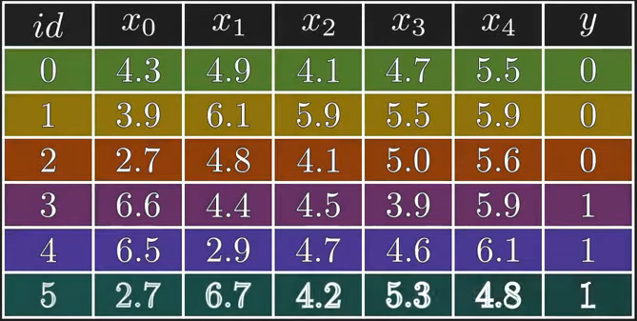

Here we are taking a small dataset with six instances and five features. As you can see target variable y takes values 0 & 1 hence it’s a binary classification.
First let us understand why do we need random forest when we already have decision tree
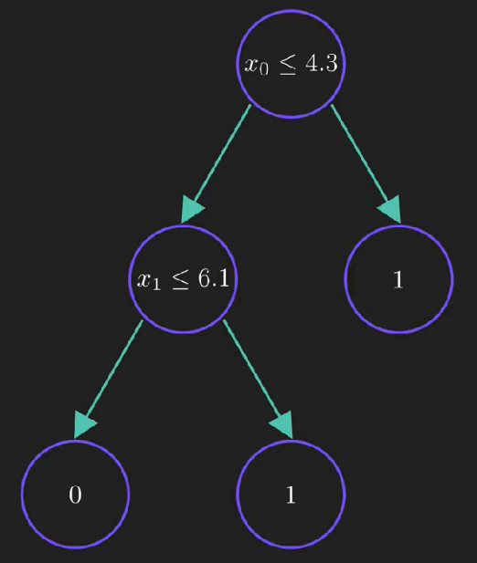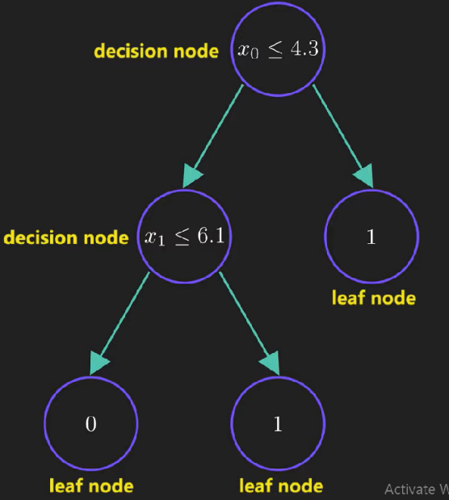
Decision tree splits the dataset recursively using decision nodes unless we are left with pure leaf nodes and its find the best split by maximizing the entropy gain.
If data sample satisfies the condition at the decision node then it moves to the left else it moves to the right child and finally reaches the leaf node where class label is assigned to it.
So, what is the problem with decision tree?
Let’s change out training data slightly. Focus on the row with id=1
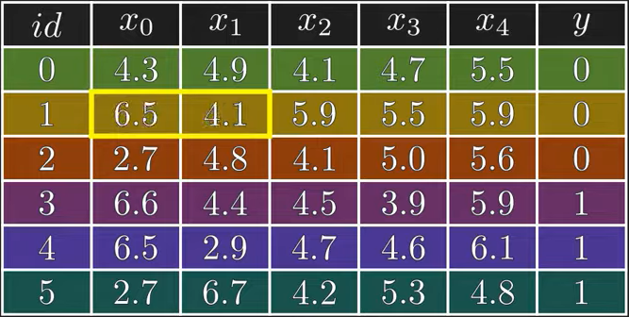
We are changing $x_{0}$ & $x_{1}$ features
If we train our tree on this modified dataset then we will get completely different tree as shown below
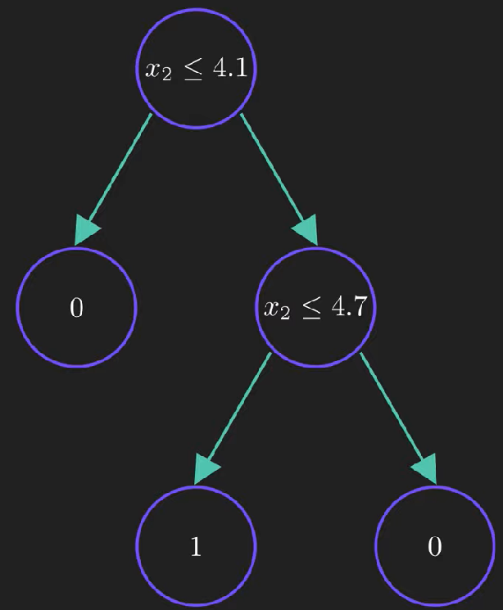
This shows us that decision tree are highly sensitive to training data which could result in high variance so our model might fail to generalize. Here comes a random forest algorithm

Random Forest: It is a collection of multiple random decision tree and it’s much less sensitive to the training data. Since we are using multiple trees hence the name forest.
Let’s understand the process of creating a random forest

Step1 : Build new dataset from the original data.
To maintain simplicity we will build only 4(this is w.r.t this example)
We will randomly select rows from original data to build new dataset and every dataset will contain the same number of rows as original one.

Here is the first dataset
id | $$x_{0}$$ | $$x_{1}$$
2 | 2.7 | 4.8
0 | 4.3 | 4.9
2 | 2.7 | 4.8
4 | 6.5 | 2.9
5 | 2.7 | 6.7
5 | 2.7 | 6.7
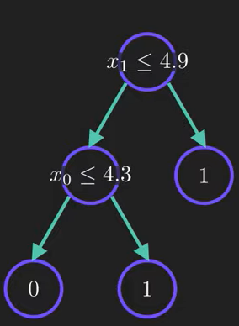
id | $$x_{2}$$ | $$x_{3}$$
2 | 4.5 | 3.9
1 | 5.9 | 5.5
3 | 4.5 | 3.9
1 | 5.9 | 5.5
4 | 4.7 | 4.6
4 | 4.7 | 4.6

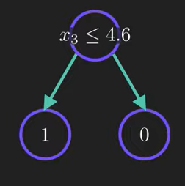
id | $$x_{2}$$ | $$x_{4}$$
4 | 4.7 | 6.1
1 | 5.9 | 5.9
3 | 4.5 | 5.9
0 | 4.1 | 5.5
0 | 4.1 | 5.5
2 | 4.1 | 5.6

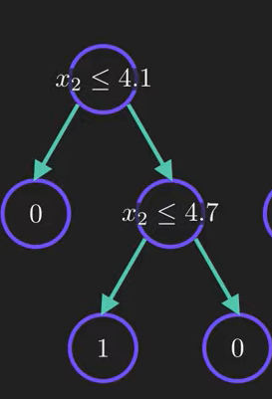

id | $$x_{1}$$ | $$x_{3}$$
3 | 4.4 | 3.9
3 | 4.4 | 3.9
2 | 4.8 | 5.0
5 | 6.7 | 4.8
1 | 6.1 | 5.5
2 | 4.8 | 5.0

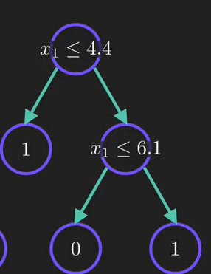
Just see how different trees look from each other and this is random forest containing 4 trees.

How to make a prediction using this forest?
Let’s consider a new data point
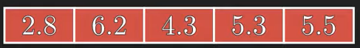
We will pass the data point through each tree one by one and note down the prediction
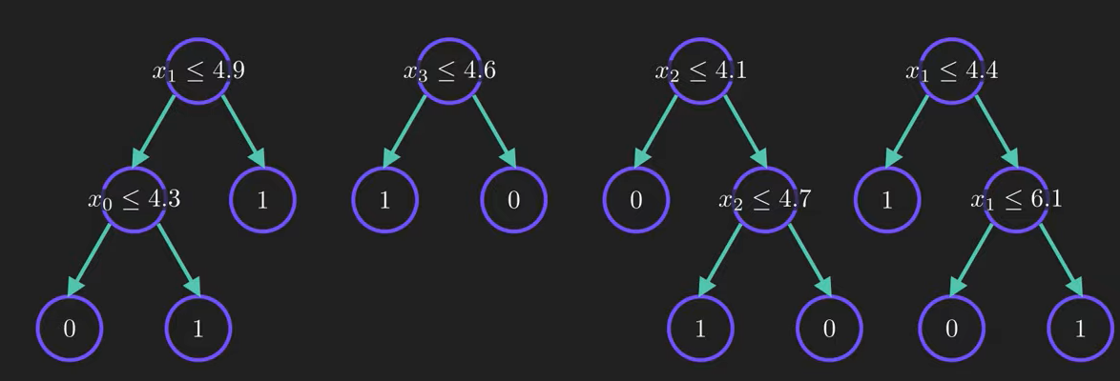
Since first tree checks condition for $x_{1}$ we will pass $x_{1}=6.2 for which it predicts output as 1$
Similarly each tree is given the value which it checks from new data point and result is noted.
Now we have to combine all the predictions
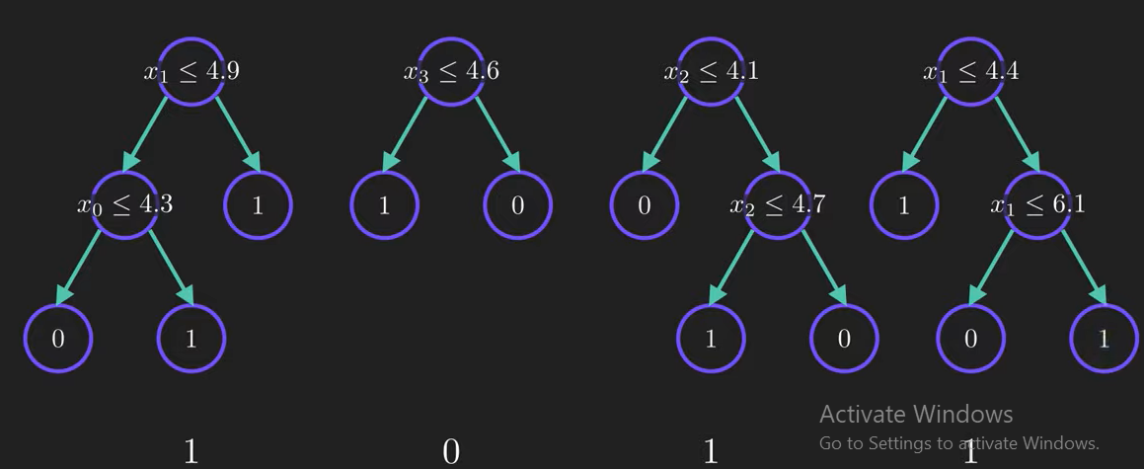
As it is the classification problem we will take majority voting. Clearly 1 is the winner hence the prediction from the random forest is 1.
This process of combining models from different process is known as aggregation.
So in random forest we first perform bootstrapping and then aggregation.

Importance of using bootstrapping
It ensures that we are not using same data for every tree so it helps our model to be less sensitive to the original training data.
The random feature selection helps to reduce correlation between the trees. If you use every feature then most of trees will have same decision nodes and they will act very similarly.
That will increase the variance
Another benefit of random forest is Some of the trees will be trained on less important features so they will give bad predictions

